**PRACTICAL – 1 (1.1)**

**AIM:**

|  |
| --- |
| **Create a program that asks the user to enter their name and their age. Printout a message addressed to them that tells them the year that they will turn 100 years old.** |

**PROGRAM:**

|  |
| --- |
| import datetime  name = input("Enter your Name: ")  age = int(input("Enter your Age: "))  date = datetime.datetime.now()  temp = 100 - age  update = temp + date.year  print(update)  print("\n20DCE019 - Yatharth Chauhan") |

**OUTPUT:**

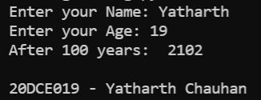

**CONCLUSION:** In this practical we learned about the usage of datetime library, input and print function.

**PRACTICAL – 1 (1.2)**

**AIM:**

|  |
| --- |
| **Write a program to ask the user for a number. Depending on whether the number is even or odd, print out an appropriate message to the user. Hint: how does an even / odd number react differently when divided by 2?** |

**PROGRAM:**

|  |
| --- |
| n = int(input("Enter Number: "))  if(n % 2 == 0):  print("Number is Even")  else:  print("Number is Odd")  print("\n20DCE019 - Yatharth Chauhan") |

**OUTPUT:**

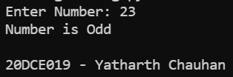

**CONCLUSION:** In this practical we learned about the usage of ‘if’ statement.